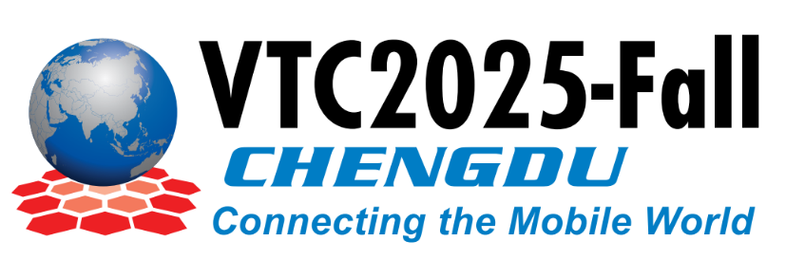



**events.vtsociety.org/vtc2025-fall**

**IMPORTANT DATES**

24 May 2025

Paper Submission Deadline

15 July 2025

Acceptance Notification

29 July 2025

Final Paper Submission

Paper submission is open:

<https://vtc2025fall.trackchair.com/>

**Chengdu, CHINA**

**19-22 October 2025**

**Call for Workshop Paper**

**Advancements and Innovations in Electric Vehicles, Vehicular Electronics, and Intelligent Transportation Systems**

The transition towards sustainable and intelligent mobility requires continuous innovation at the intersection of electric vehicle (EV) technology, vehicular electronics, and intelligent transportation systems (ITS). This workshop aims to address state-of-the-art developments, bringing together academia, industry practitioners, policymakers, and researchers to explore the latest advancements in electric vehicles, vehicular electronics, autonomous driving technologies, and smart transportation solutions.

Topics covered will include emerging battery and charging technologies, power electronics integration, advanced autonomous driving capabilities, Vehicle-to-Everything (V2X) communications, Internet of Things (IoT) in vehicular environments, intelligent infrastructure deployment, cybersecurity concerns, and sustainable policy frameworks. Attendees will gain insights into groundbreaking research and practical implementation challenges through technical paper presentations, interactive panel discussions, and poster sessions designed for networking and fostering collaboration among participants.

We invite original contributions covering, but not limited to, the following topics:

* Advances in electric vehicle battery and storage systems
* Innovative charging infrastructure and smart grid integration
* Autonomous driving technologies and vehicular control algorithms
* Vehicle-to-Everything (V2X) communications technologies and applications
* Intelligent transportation systems powered by IoT and edge computing
* Power electronics and vehicle electronics integration
* Cybersecurity, privacy, and trust management in connected vehicles
* Smart grid and renewable energy integration for EV infrastructure
* Fleet optimization and sustainable mobility strategies
* Policy developments and regulatory frameworks for EV and ITS deployment



**Co-Organizers**

**Zahid Khan,** Prince Sultan University, Kingdom of Saudi Arabia

**Donghong Cai,** Jinan University, China

**Wadii Boulila,** Prince Sultan University, Kingdom of Saudi Arabia

**Pingzhi Fan,** Southwest Jiaotong University, China